Ancient Mesopotamia
- Below is a map of modern day Southwest Asia (Middle East). Circle where Ancient Mesopotamia was located.
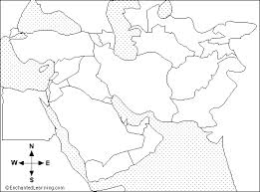
- Polytheism is defined as: A Religion with more than one god.
Monotheism is defined as: A Religion with only one god.
Ancient Mesopotamia: Polytheistic? Or Monotheistic? Explain your answer.

- List the people/professions that made up each social class in Ancient Mesopotamia.
High: ____________________________________________________
Middle: __________________________________________________
Low: ____________________________________________________
- Inventions of Ancient Mesopotamia: Explain the impact each invention had on Ancient Mesopotamia AND later in history.

- Written Communication in Ancient Mesopotamia looked like this: 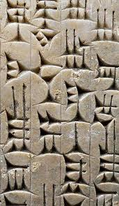
What was is called? And why was it called this?

- Influence in Mathematics: geography, 60-minute hour, 360 degree circle, and 60 second minute.
Pick one of these mathematical influences and describe/explain how you have used it in your everyday life (do not use math class as an answer).

Ancient Egypt
- Below is a map of modern day Southwest Asia (Middle East). Circle where Ancient Egypt was located.
- Polytheism is defined as: A Religion with more than one god.
Monotheism is defined as: A Religion with only one god.
Ancient Egypt: Polytheistic? Or Monotheistic? Explain your answer.

- List the people/professions that made up each social class in Ancient Egypt.
High: ____________________________________________________
Middle: __________________________________________________
Low: ____________________________________________________
- Inventions of Ancient Egypt: Explain the impact each invention had on Ancient Mesopotamia AND later in history.
Written Communication in Ancient Egypt looked like this: 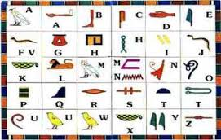
- What was is called? And why was it called this?

- Influence in Mathematics: Number system based on 10, adding fractions with whole numbers.
Pick one of these mathematical influences and describe/explain how you have used it in your everyday life (do not use math class as an answer).

