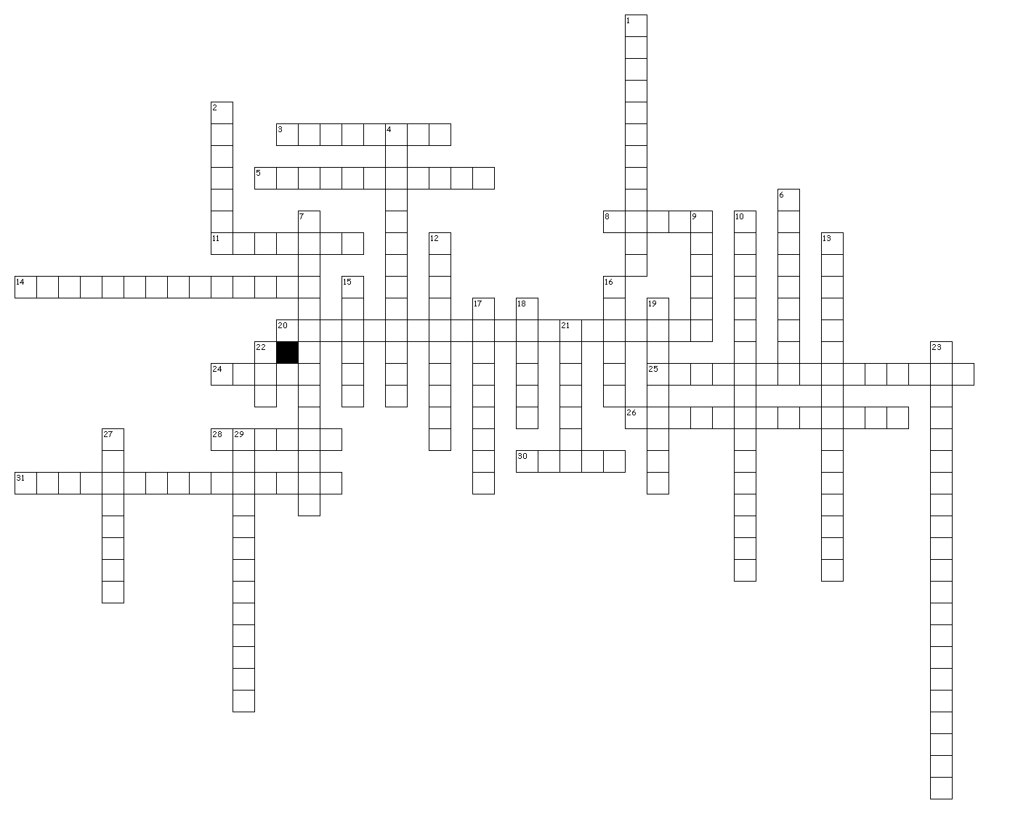
Across
3. one who buys the goods or services produced/offered.
5. hiring workers from other countries to carry out tasks.
8. something that is intended to satisfy some wants or needs of a consumer.
11. the wealth and resources of a country, state, etc.
14. setting rules for deciding what goods and services to produce, how to sell them, and who will receive them.
20. an economy based on economies of all the world's countries.
24. an exchange of items/goods.
25. when countries rely on each other for ideas, goods, services, and markets.
26. development of a worldwide culture with an interdependent economy.
28. the want of a product.
30. number limit on how many items can be imported from a certain nation.
31. a single country's economic system.
Down
1. economic system that has both government and individual influence on what is produced, what resources are used, how much it will be sold for, and how many of it will be produced.
2. action taken typically for a payment.
4. system where individuals set rules for deciding what goods and services to produce, how to sell them, and who will receive them.
6. a reward offered.
7. economic system in which the government decides how resources are used and what goods are produced.
9. what is available.
10. describes the flow of money and products throughout an economy.
12. system allowing people to make free economic choices and unlimited amounts of money.
13. limits placed on trade between two or more countries.
15. agreement made between two or more countries.
16. the difference between making a good and selling the good.
17. government system that controls the ways of producing goods.
18. tax that is sometimes added to the price of goods that are imported from other countries.
19. economic system where ownership is had by the community, not individuals, in an attempt to keep things more "equal".
21. ban on trade with a particular country.
22. a fee charged by the government on a product, service, income, or activity.
23. chances to make or spend money.
27. one who makes goods.
29. a pattern of money activity measured over a long period of time.

