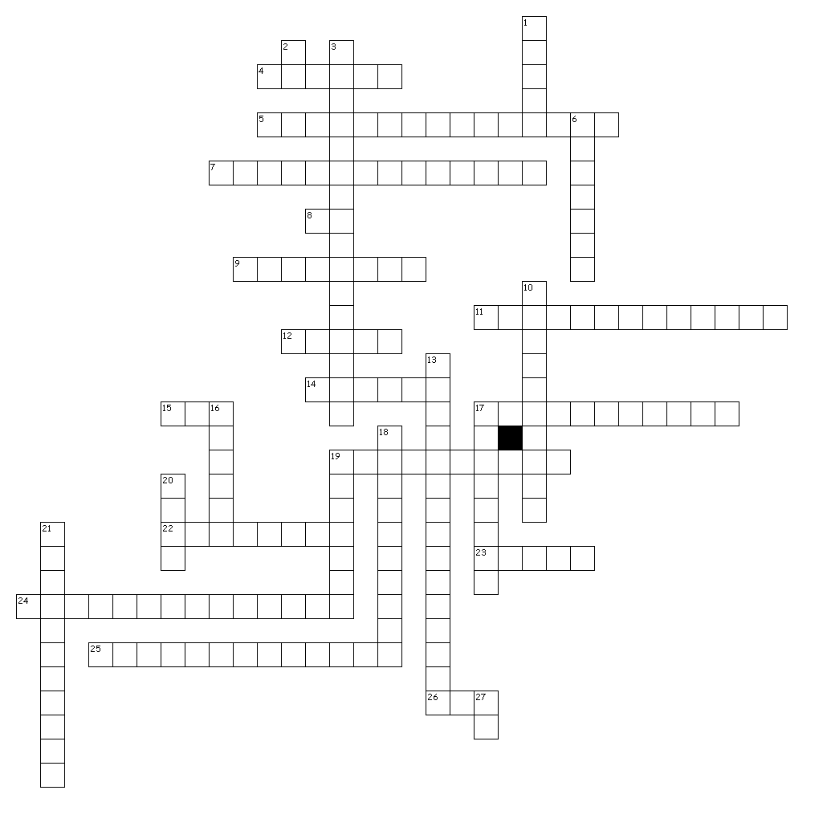
Across
4. a block of time
5. Pgs. TOOLS 8 and 9 in your textbook.
7. Collection of maps showing parts of the world throughout history.
8. In Western calendar systems years prior to the birth of Crist are referred to as this.
9. Diagram showing the order of events.
11. My diary
12. Not brushing your teeth is an example of this because you then will get a cavity.
14. If you have lived for ten years you could be considered this old.
15. Before Current Era
17. Truthfulness of an artifact or person.
19. When looking at a timeline and dates are in order in which they occurred.
22. evidence from the past
23. Look at this to view numerous maps of the world.
24. The study of time from early civilizations to about 500 AD/CE.
25. Time period ranging from 1500 AD/CE to present day.
26. a block of time
Down
1. CIRCA 1933
2. Current Era
3. Silk Road, Route 66, Trail of Tears (pg. TOOLS 9).
6. Historians do this with artifacts past to better understand the past.
10. Also known as Medieval Times, time period ranging from 500 AD/CE to 1500 AD/CE.
13. a textbook
16. Getting a cavity because you did not brush your teeth.
17. Many cultures past and present have their own. This allows historians to date and measure time.
18. Before people could read and write, roughly 5,500 years ago.
19. One hundred years.
20. Favoring of an idea due to a personal connection.
21. Your general attitude of a person or idea.
27. Annio Domini, Latin for "Year of the Lord." NOT AFTER DEATH.
29 of 29 words were placed into the puzzle.

