Vocabulary:
International Date Line- an imaginary line on the surface of the Earth, established in 1884, that runs from the north to the South Pole and separates one calendar day from the next. The line passes through the middle of the Pacific Ocean, roughly following the 180° longitude but it moves in some areas to pass around some territories and island groups.
Scenario:
Assume you are a tour manager for your favorite band/group (__________________). Your job is to fill out the chart below. You have a tour of cities provided for you (what type of map will you probably have to use?) ____________________. You will have to convert the times of your tour cities and the time back here in Clio. It is important to also give the time back here in Clio because your lead singer calls his/her mom each night, he/she just loves talking to mommy! Use textbook pages RA 32 and RA 33 to help you.
Tour Cities | Clio, MI (Eastern Standard Time)
Edmonton, Canada: | 10:30 pm
Rome, Italy: 7:00 am
Hong Kong, China: | 4:00 am
Istanbul, Turkey: 12:00 pm
Cape Town, South Africa: | 8:40 pm
Santiago, Chile: 1:00am
Sydney, Australia: | 9:00 am
Washington, D.C.: 8:00 am

Story Problems:
- If your flight is leaving Tokyo, Japan at 1:15 pm, it is a 6 hour flight, and you are going to Mekka (Mecca), Saudi Arabia, what time is it when your flight is scheduled to arrive?
  - Answer:
  - Explanation:
Returning home: Your flight to return back to Tokyo, Japan is scheduled to leave at 8:00 am. It is now an 8 hour flight back due to a layover in New Delhi, India. What time is your return flight from Mekka, Saudi Arabia to Tokyo, Japan scheduled to arrive?
  - Answer:
  - Explanation:

- You are sitting in your corporate office in Cairo, Egypt. You are scheduled to have a video conference with the CEO of Nike, who is in Oregon, about a new line of athletic clothing. If the CEO tells you that he expects you to joining the video conference at 4:00 pm Oregon time (Pacific Time Zone) what time will the video conference be held in Cairo, Egypt?
  - Answer:
  - Explanation

- Draw the International Date Line. Also, label the following: Pacific Ocean, North America, Asia, and Australia.

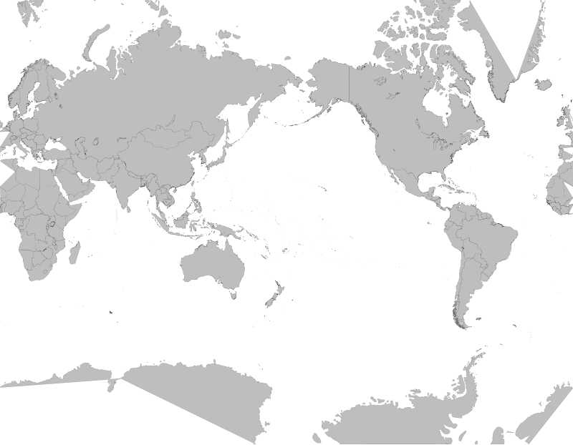

****If it is 10:00 pm in Honolulu, Hawaii, what time is it in Singapore, Singapore?
- Answer:
- Explanation:

